Purpose:

After reading this document, readers will be able to invoke a REST API call for refreshing Power BI dataset using Power Shell.

Initially we will prepare a dataset and will prepare the report.

Dataset:

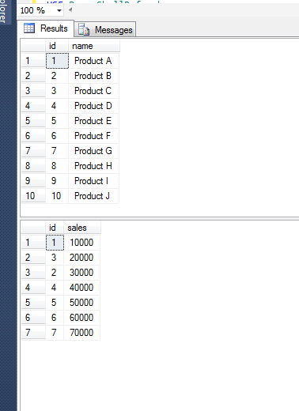

Now the report:

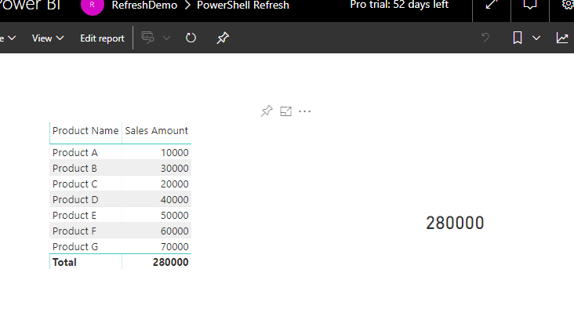

Now you can download the data gateway and configure it to dataset and make sure you are not scheduling it.

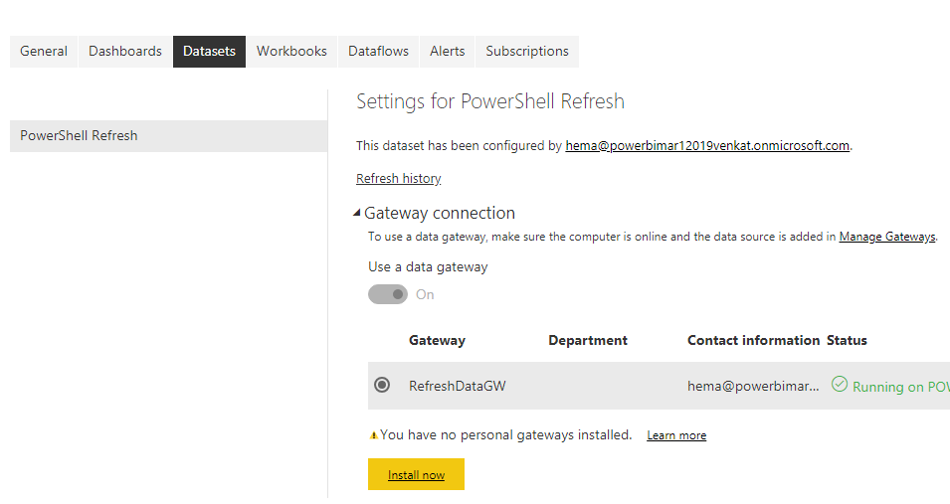

From the above screen, have just tagged the data gate way to the dataset. After this, we need to register an application for Invoking RESP API.

We can create the application from portal.azure.com or dev.powerbi.com/apps

I am creating using Azure portal.

